[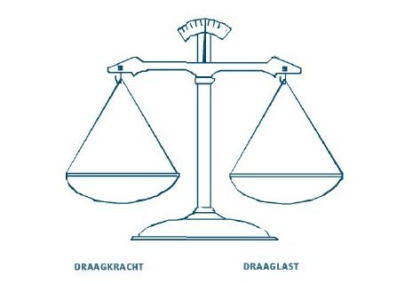](https://www.google.nl/url?sa=i&rct=j&q=&esrc=s&source=images&cd=&cad=rja&uact=8&ved=2ahUKEwjRosHZjYneAhVQKVAKHQY3BqkQjRx6BAgBEAU&url=http://www.depri-en-dan.nl/oorzaken&psig=AOvVaw3ZhVkCQHxLSpKbXMSQ5pLp&ust=1539715467435056)

|  |  |
| --- | --- |
|  |  |
|  |  |
|  |  |
|  |  |
|  |  |
|  |  |
|  |  |
|  |  |
|  |  |
|  |  |
|  |  |